DEAL: A Common Executable Language for Human–AI–Machine Communication
Language Design, Compiler Architecture, and Empirical Evaluation
Working Manuscript — Version 3
DEAL (Declarative and Extensible Abstract Language) / DEAL.JS implementation

Mohammad Fathi
0000-0002-2203-2631, i@mimfa.net,
Ph.D. Candidate, Department of Knowledge and Information Science University of Isfahan, Isfahan, Iran
Mehrdad CheshmeSohrabi
0000-0003-1856-4210, mo.sohrabi@edu.ui.ac.ir,
Professor, Department of Knowledge and Information Science University of Isfahan, Isfahan, Iran
Ahmad Shabani
0000-0002-2203-2631, shabania@edu.ui.ac.ir,
Professor, Department of Knowledge and Information Science University of Isfahan, Isfahan, Iran
Ali Mansouri
0000-0003-4047-2697, a.mansouri@edu.ui.ac.ir,
Assistant Professor, Department of Knowledge and Information Science University of Isfahan, Isfahan, Iran

https://github.com/deal-x

Abstract
Large language models have made natural-language requests a practical interface for program generation, but generated source code can remain difficult for domain experts to verify when they are not professional programmers. This challenge is related to—but distinct from—the broader opacity of neural models: the internal computation of a model may be difficult to explain, while the program it produces can still be represented, inspected, tested, and translated through an explicit software pipeline. This paper presents DEAL (Declarative and Extensible Abstract Language), with DEAL.JS as its current JavaScript-targeting implementation, as a constrained, human-readable, AI-generatable programming language intended to provide a common executable representation between human intent, AI systems, and target-language code. DEAL uses natural-language-like declarative instructions, interoperates directly with ordinary JavaScript, provides `USE`-based module inclusion and `RESERVE`-based vocabulary/noise-word mechanisms, and organizes commands into action, function, definition, and delegation forms. The DEAL.JS implementation reuses JavaScript compiler stages through a staged C# engine; the repository also contains a more general engine core with explicit token, node, walker, resource-provider, stage, and diagnostic abstractions. We describe the language model, syntax, compiler design, and web-data-extraction workflow, and situate the design in research on natural-language-oriented programming, extensible languages, end-user development, and program synthesis. We evaluated compiler conformance, deterministic builds, AI-generated tasks, human comprehension, vocabulary localization, and reproducibility.

Keywords: programming-language design; AI-assisted programming; end-user development; source-to-source compilation; language extensibility; multilingual programming; program synthesis; web data extraction.

1. Introduction
The growing availability of generative AI changes the practical relationship between a person with a computational problem and the source code needed to solve it. A researcher may know the scientific question, input data, and desired transformation without being fluent in the syntax, libraries, debugging practices, or runtime constraints of a general-purpose language. Natural-language-to-code systems can reduce the initial coding barrier, but program-generation quality must be assessed by executable behavior rather than by the fluency of a response. Code-generation research has therefore emphasized functional correctness and more rigorous test suites [1,2].
A separate literature studies the limited transparency of complex AI systems [3]. DEAL is not a method for opening the internal weights or reasoning processes of neural networks, and it should not be positioned as a solution to model interpretability. Instead, DEAL targets an adjacent problem in the human–AI programming workflow: how can the program generated or edited by an AI system be represented in a form that is simultaneously readable by a human, constrained enough for deterministic compilation, and close enough to an established programming language to remain executable and extensible?
DEAL addresses this problem by introducing a source language between unstructured intent and ordinary target-language code. The human or an AI system writes DEAL instructions; the compiler translates them to target-language source; and the generated source becomes an explicit artifact for inspection, testing, reuse, and execution. DEAL does not attempt to execute unrestricted natural-language sentences. It adopts constrained grammar inspired by natural-language structure, whose instructions have defined compilation behavior. DEAL.JS currently targets JavaScript and permits ordinary JavaScript to coexist within the same program.
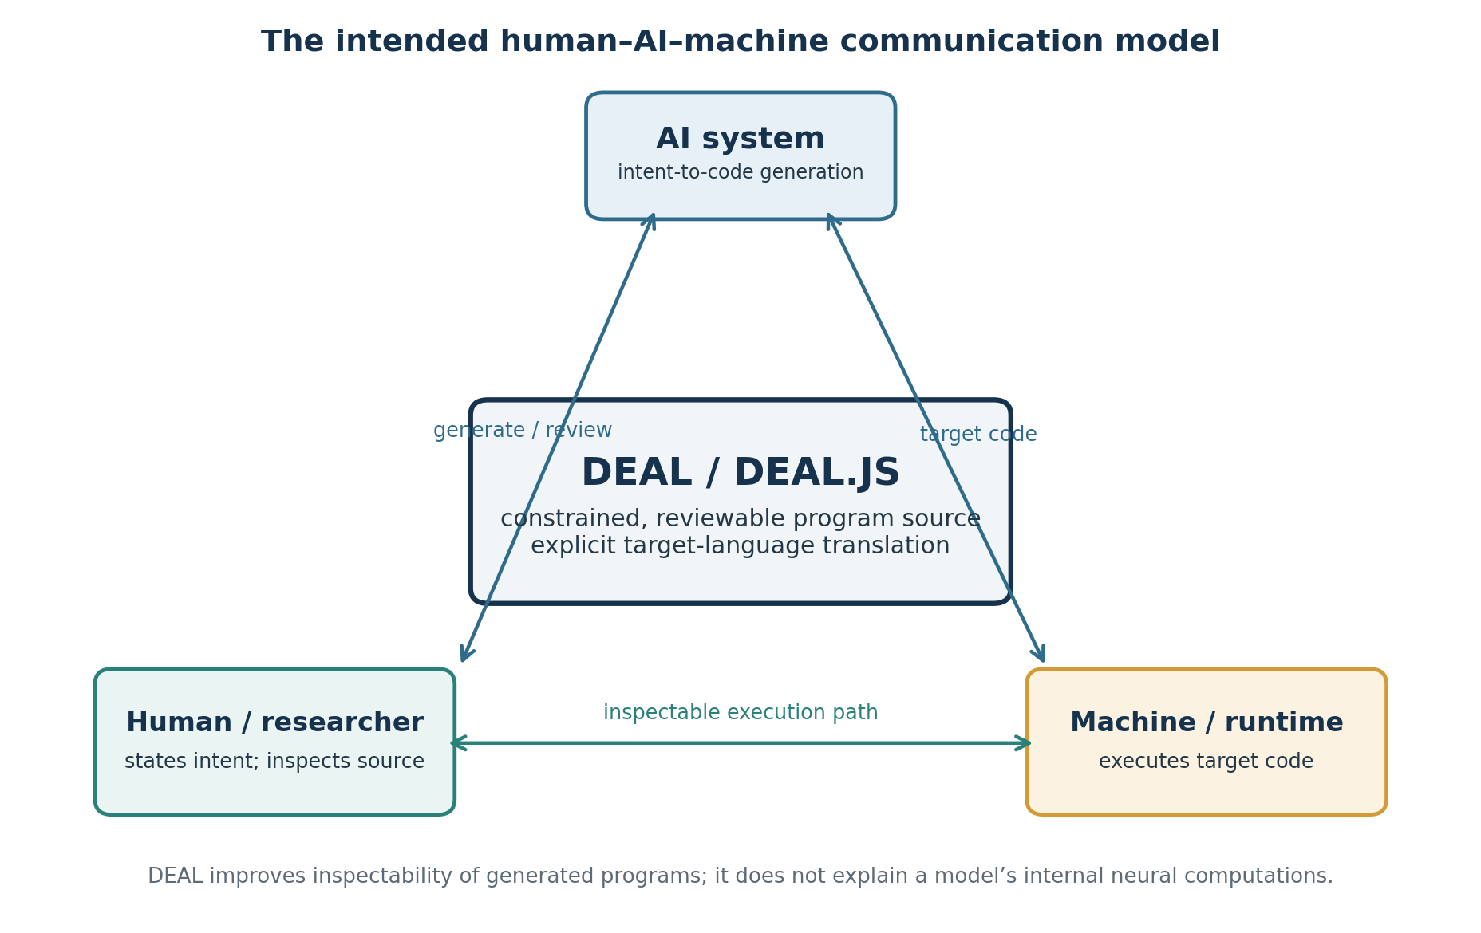
Figure 1. DEAL’s intended communication model. The central proposition is an inspectable program representation, not an explanation of the AI model’s internal computation.
The DEAL.JS repository provides a concrete implementation rather than only a conceptual proposal. Its README specifies the language’s principles and syntax, sample programs demonstrate the source notation and generated JavaScript, and the C# code layers DEAL-specific tokenization, parsing, and assembly over a JavaScript compiler engine. A separate generic engine project defines reusable compiler abstractions, including token and node models, walkers, resource access, pipeline stages, and diagnostics. The research contribution lies in the design and integration of these mechanisms for a human–AI–machine workflow, together with a systematic empirical assessment of their properties.
This paper makes five contributions: (1) it defines DEAL’s design problem and requirements; (2) it describes the five core language principles and the documented instruction model; (3) it reports the architecture of the JavaScript-targeting compiler and the reusable engine layer; (4) it presents data-extraction examples and compares DEAL with related language systems; and (5) it specifies and reports an evaluation program for conformance, deterministic output, AI generation, human comprehension, localization, and reproducibility. The exact measured outcomes are reserved for author insertion in this working draft.

2. Problem statement and motivation

2.1 The gap between intent and verifiable source code
Conventional source code is precise and executable, but that precision comes with notational and conceptual demands. A user must understand control flow, identifiers, function contracts, error handling, dependencies, and environmental behavior to review a program with confidence. AI-generated code does not remove those responsibilities. EvalPlus shows why limited test suites can overestimate functional correctness and motivates stronger execution-based verification [1]. HumanEval similarly frames code generation as a functional-correctness problem rather than a natural-language fluency problem [2].
DEAL’s design hypothesis is that a constrained, human-readable source form can create an intermediate point at which a user can review the computational plan before it is translated into ordinary code. In this model, an AI system is not asked to invent arbitrary syntax: it generates a finite language with explicit structural rules. The compiler then turns that representation into target-language code which can be inspected or tested. This does not guarantee that the generated program is correct, but it creates a stable artifact to which compiler tests, semantic tests, and human review can be applied.

2.2 The proper scope of the “black-box” motivation
Research on explainable AI characterizes the opacity of some machine-learning systems as a major challenge for explaining their predictions or internal behavior [3]. DEAL addresses a different layer. It does not expose model parameters, explain a neural inference, or establish causal accounts of a model’s outputs. It instead aims to make the *program artifact* exchanged between AI and a user more explicit, constrained, and verifiable. This distinction avoids conflating language-based program representation with model interpretability.

2.3 Why unrestricted natural language is not the target
Natural-language programming research predates current generative models. An early experiment with the NLC system found that users could express computational tasks through English sentences, but also observed rejected inputs and limits imposed by the system’s accepted syntax [4]. A later study of natural-language notations concluded that natural language may help comprehension and debugging while creating difficulties for program generation [5]. These findings inform DEAL’s central constraint: familiar grammatical forms are used to express instructions, but the accepted syntax remains bounded and formally processed. The intended advantage is not that ambiguity disappears from English; it is that the language defines a controlled subset for which compilation rules can be specified and tested.

2.4 The intended user
The primary intended users are researchers, analysts, and domain specialists who need repeatable computational procedures but do not necessarily identify as professional programmers. This motivation is consistent with end-user development, which studies how non-specialists create or modify digital artifacts and the engineering practices needed to support them [6]. The target audience must still be validated empirically: researchers in one domain may not share the same needs, terminology, or tolerance for formal syntax as users in another domain.

3. Research questions and objectives
The completed evaluation is organized around research questions that make the paper’s claims falsifiable. The precise operational definitions, study metadata, and measured outcomes are reported in Sections 9–10; fields not reproduced from the completed study record are highlighted for author completion.
RQ | Research question | Primary evidence
RQ1 — compiler correctness | Does DEAL.JS preserve the intended behavior of supported JavaScript and DEAL instructions? | Conformance corpus, execution-based differential tests, mismatch classification.
RQ2 — determinism | Does repeated compilation of the same source under the same version/configuration produce stable output? | Repeated-build comparisons, environment/configuration records.
RQ3 — AI generation | For matched tasks, does generation in DEAL improve validity or functional correctness compared with direct JavaScript generation? | Controlled prompts, compile/test success, repair turns, cost.
RQ4 — human comprehension | Can intended users understand and verify DEAL programs more accurately or efficiently than matched JavaScript programs? | Task accuracy, completion time, confidence/workload, statistical analysis.
RQ5 — vocabulary localization | Can alternative vocabulary modules express equivalent instructions without changing observable semantics? | Paired localized fixtures and target-behavior equivalence.
RQ6 — overhead and reproducibility | What are compilation costs, target-code characteristics, and artifact reproduction results? | Latency, memory/output size if measured, pinned versions, scripts, logs.

The objectives are consequently: define a constrained language for computational intent; preserve interoperability with JavaScript; provide module-based capabilities and vocabulary adaptation; implement a compiler whose stages can be inspected independently; and evaluate rather than assume gains in reliability, readability, or productivity.

4. Related work

4.1 Natural-language-oriented programming
Biermann, Ballard, and Sigmon conducted an experimental study of English as a programming language, demonstrating early interest in letting users formulate tasks through natural-language sentences [4]. Lopes et al. argued for naturalistic programming approaches that align computational abstractions with the ways people describe concerns [7]. Good and Howland’s studies later emphasized that natural-language syntax can have different effects across program comprehension, debugging, and generation tasks [5]. DEAL takes a constrained-language position: surface instructions resemble natural language, but syntax is not unrestricted and each supported instruction is processed by a compiler.

4.2 End-user development and DSL evaluation
The end-user development literature provides a relevant context for languages intended for domain specialists. Barricelli et al.’s systematic mapping study surveyed end-user development, end-user programming, and end-user software engineering, while Barisic et al. argued that claims about DSL usability and productivity require systematic evaluation rather than anecdotal demonstration [6,8]. DEAL’s intended accessibility therefore needs both language-level validation and user studies with representative participants. Readability is a design target, not an outcome that can be inferred solely from the appearance of source code.

4.3 Language extensibility
SugarJ shows how syntax extensions can be packaged as libraries, imported, and composed within a host language [9]. DEAL shares the high-level aim that extension should be modular and reusable, but its documented mechanism focuses on `USE`-based inclusion and vocabulary behavior, including `RESERVE` replacements and noise words. These mechanisms should be distinguished from SugarJ’s syntax-extension and incremental-parsing machinery; the comparison is about the design concern, not an assertion of equivalent semantics or guarantees.

4.4 JavaScript as a target and interoperability model
TypeScript extends JavaScript with a gradual type system, modules, classes, and interfaces while retaining JavaScript as its output target [10]. DEAL’s objective differs: its central concern is a higher-level, natural-language-like instruction layer and an interface between human intent and AI-assisted programming. DEAL.JS shares with TypeScript the practical benefits of reusing the JavaScript ecosystem, but not TypeScript’s primary type-system contribution. Research on translating Curry to JavaScript is another precedent for translating a declarative language into browser-executable JavaScript [11].

4.5 Web automation and extraction
WebL was designed for Web document processing and automation, with constructs for document access and web-oriented workflows [12]. It is relevant to DEAL’s scraper-oriented examples, which combine requests, page loading, selectors, value conversion, and output persistence. DEAL’s intended scope is broader than a single web automation DSL because it allows ordinary JavaScript and proposes a module-defined vocabulary across domains.

4.6 Positioning relative to prior systems
System / approach | What it contributes | Difference in relation to DEAL
Unrestricted natural-language-to-code prompts | Flexible expression of user goals; AI synthesizes source [1,2]. | DEAL constrains the intermediate program notation and provides explicit compiler rules.
Natural-language programming research [4,5,7] | Human-oriented notation and evidence on comprehension/generation trade-offs. | DEAL combines bounded syntax with current AI generation and target-language translation.
TypeScript [10] | Structured JavaScript extension with type-system support and JS output. | DEAL emphasizes intent-level instructions and vocabulary extension, not static typing.
SugarJ [9] | Library-oriented syntax extension. | DEAL’s documented `USE`/`RESERVE` mechanism targets modules and vocabulary within its parser design.
WebL [12] | High-level language for web processing and automation. | DEAL includes hybrid JavaScript interoperability and a general communication-layer objective.
Curry-to-JavaScript [11] | A declarative language translated to JavaScript. | DEAL focuses on readable instructions, module vocabulary, and human/AI review workflow.

No novelty claim should be based on saying that earlier languages lacked readability, extensibility, web automation, or JavaScript compilation individually. The defensible research question is whether DEAL’s specific integration of constrained natural-language-like source, ordinary JavaScript interoperability, modular vocabulary, and an explicit AI–human–machine workflow produces measurable benefits. The final submission should state this novelty in relation to a systematic and up-to-date literature search.

5. DEAL language design

5.1 Definition and intended role
DEAL (Declarative and Extensible Abstract Language) is a human-readable, AI-generatable, and machine-executable programming language designed to provide a common communication layer between human intent, AI systems, and executable software. DEAL.JS is the current implementation that compiles DEAL instructions and interoperable JavaScript source into JavaScript. In this paper, “intermediate language” describes DEAL’s role in the Human → DEAL → target-code workflow; it does not mean that DEAL is only an internal compiler representation. It is intended to be written, generated, inspected, modified, and reused as source code.

5.2 Five design principles
Principle | Language-level meaning | Evidence / validation
1. Declarative and abstract | Instructions express computational intent in constrained, natural-language-like structures, rather than exposing every target-language detail at each use site. | Syntax examples and command abstractions; comprehension evaluation [evidence/results].
2. Deterministic and explicit | Each accepted instruction has defined compilation semantics; interpretation does not depend on runtime guessing about the intended grammar. | Compiler specification and conformance suite [version and result].
3. Hybrid and interoperable | Ordinary JavaScript can coexist with DEAL instructions in the same source file. | JavaScript stress corpus and mixed-source tests [pass count].
4. Modular and extensible | `USE` introduces libraries/resources; `RESERVE` supports vocabulary replacements and semantically ignored noise words, while core structures remain compiler-defined. | Module and localization fixtures [module IDs and result].
5. Consistent and reusable | Higher-level commands represent reusable behavior, and the generated target-language program serves as the executable artifact. | Command test suite and code reuse study [metric/evidence].

The phrase “generated target code is the executable truth” expresses a practical principle: execution occurs in the target language, so the generated program remains available for inspection and testing. This does not mean that generated output is automatically correct, secure, or optimized; those properties require separate evidence.

5.3 Core concepts
The DEAL.JS README organizes the language around four concepts: structures, commands, reserves, and handlers. Structures define the core grammar and cannot be overridden through ordinary command definitions. Commands represent executable operations, may be built in, imported, or user-defined, and are documented in four forms. Reserves provide readability vocabulary without adding a new runtime function by themselves. Handlers expose values associated with the active execution context, such as the current browser/window/tab/document and the latest response or load/fetch status [13].
Concept | Documented behavior | Example forms
Structures | Compiler-recognized grammar and control structures. | IF/ELSE; FOR EACH; WHILE; BEGIN…END; DOING; TRY/CATCH/FINALLY; WILL…THEN…OTHERWISE…ANYWAY.
Commands | Executable operations supplied by the language, modules, or program author. | Action, function, definition, delegation.
Reserves | Case-insensitive readability words mapped to replacement text or skipped as noise. | RESERVE into AS ","; RESERVE the;.
Handlers | Context-sensitive identifiers reflecting the current workspace/thread. | BROWSER, APPLICATION, WINDOW, TAB, DOCUMENT, RESPONSE, LOADED, FETCHED, DATA, ITS.

5.4 Structures and control flow
The documentation introduces conditional execution through `IF … ELSE`, collection iteration through `FOR` or `FOR EACH` with `OF`/`IN`, conditional loops through `WHILE`, and post-condition loops through JavaScript-compatible forms. `BEGIN … END` and `DO … END` delimit procedure blocks; `DOING … END` describes a callable block; `TRY … CATCH … FINALLY` expresses exception-handling structure. A `WILL … THEN … OTHERWISE … ANYWAY` form is documented as a promise-oriented threading pattern. DEAL also documents collection expressions such as `WHERE`, `ORDER BY`, and `LIMIT`, which translate to JavaScript array operations [13].

5.5 Commands and reusable abstractions
The command model is a key abstraction mechanism. Action commands are introduced using one or more `#` signs before a command name, execute their procedure when defined, and can later be called by name. Function commands follow a `COMMAND name(parameters) { … }` pattern and compile to JavaScript functions. Definition commands describe object-like properties. Delegation commands allow references to existing variables, functions, classes, or constants with a case-insensitive aliasing convention introduced by `#` or asterisks in the documented forms. The command model creates an intermediate level of vocabulary above raw target-language expressions while leaving JavaScript functions and objects available.
COMMAND normalizeTitle(value = "") {
return normalize(value);
}
# PrepareReport
Begin,
result = normalizeTitle(rawTitle);
append destination, result;
End;
The example illustrates the intended relationship between a named command and later instructions. Exact source validity, generated output, and semantics should be represented in the project’s test fixtures rather than inferred from the sketch alone.

5.6 Reserved words, noise words, and casing
A reserved word can be given a replacement string using `RESERVE reservedWordName AS "replacement";`. The README illustrates mapping `into` to a comma or mapping a readable alias such as `restart` to a longer instruction. A noise word is registered using `RESERVE noiseWordName;`; the word is ignored semantically but remains in the readable source. For example, registering `the` allows `CLICK ALL THE #nextbutton` to be interpreted like `CLICK ALL #nextbutton`. Both groups are described as case-insensitive. The language also distinguishes grammar/command/handler tokens from user-defined names and object properties, which remain case-sensitive in the documented convention [13].

5.7 Modules and the USE mechanism
`USE` attaches a core library, a specific resource, a directory, or an external library path. According to SAMPLE.md, package resolution checks for a `.djs` resource, then a `.js` resource, and then a directory whose files can be included. This enables a program to import domain functionality without embedding every definition in the primary source. The repository’s built-in library tree includes core statements, functions, identifiers, operators and noise words; data utilities; selectors; handlers; type conversion; and web-transfer functionality [13]. A research-ready language specification should define the exact resolution order, conflict behavior, module isolation, and build reproducibility constraints.

5.8 Localization and the common semantic core
The design permits modules that introduce alternative vocabulary, potentially for Spanish, French, German, or other languages. In the documented Spanish illustration, a localized instruction such as “Para cada url de la lista, carga la url…” is intended to correspond to an English form such as “For each url of the list, load the url…”. The important property is not that source code is automatically translated between natural languages; it is that module-defined words can map onto the same language instructions without changing the underlying compiler model. The author’s completed localization implementation should be described here using the actual module paths and supported vocabulary: [supported languages, modules, equivalence test count, outcome].
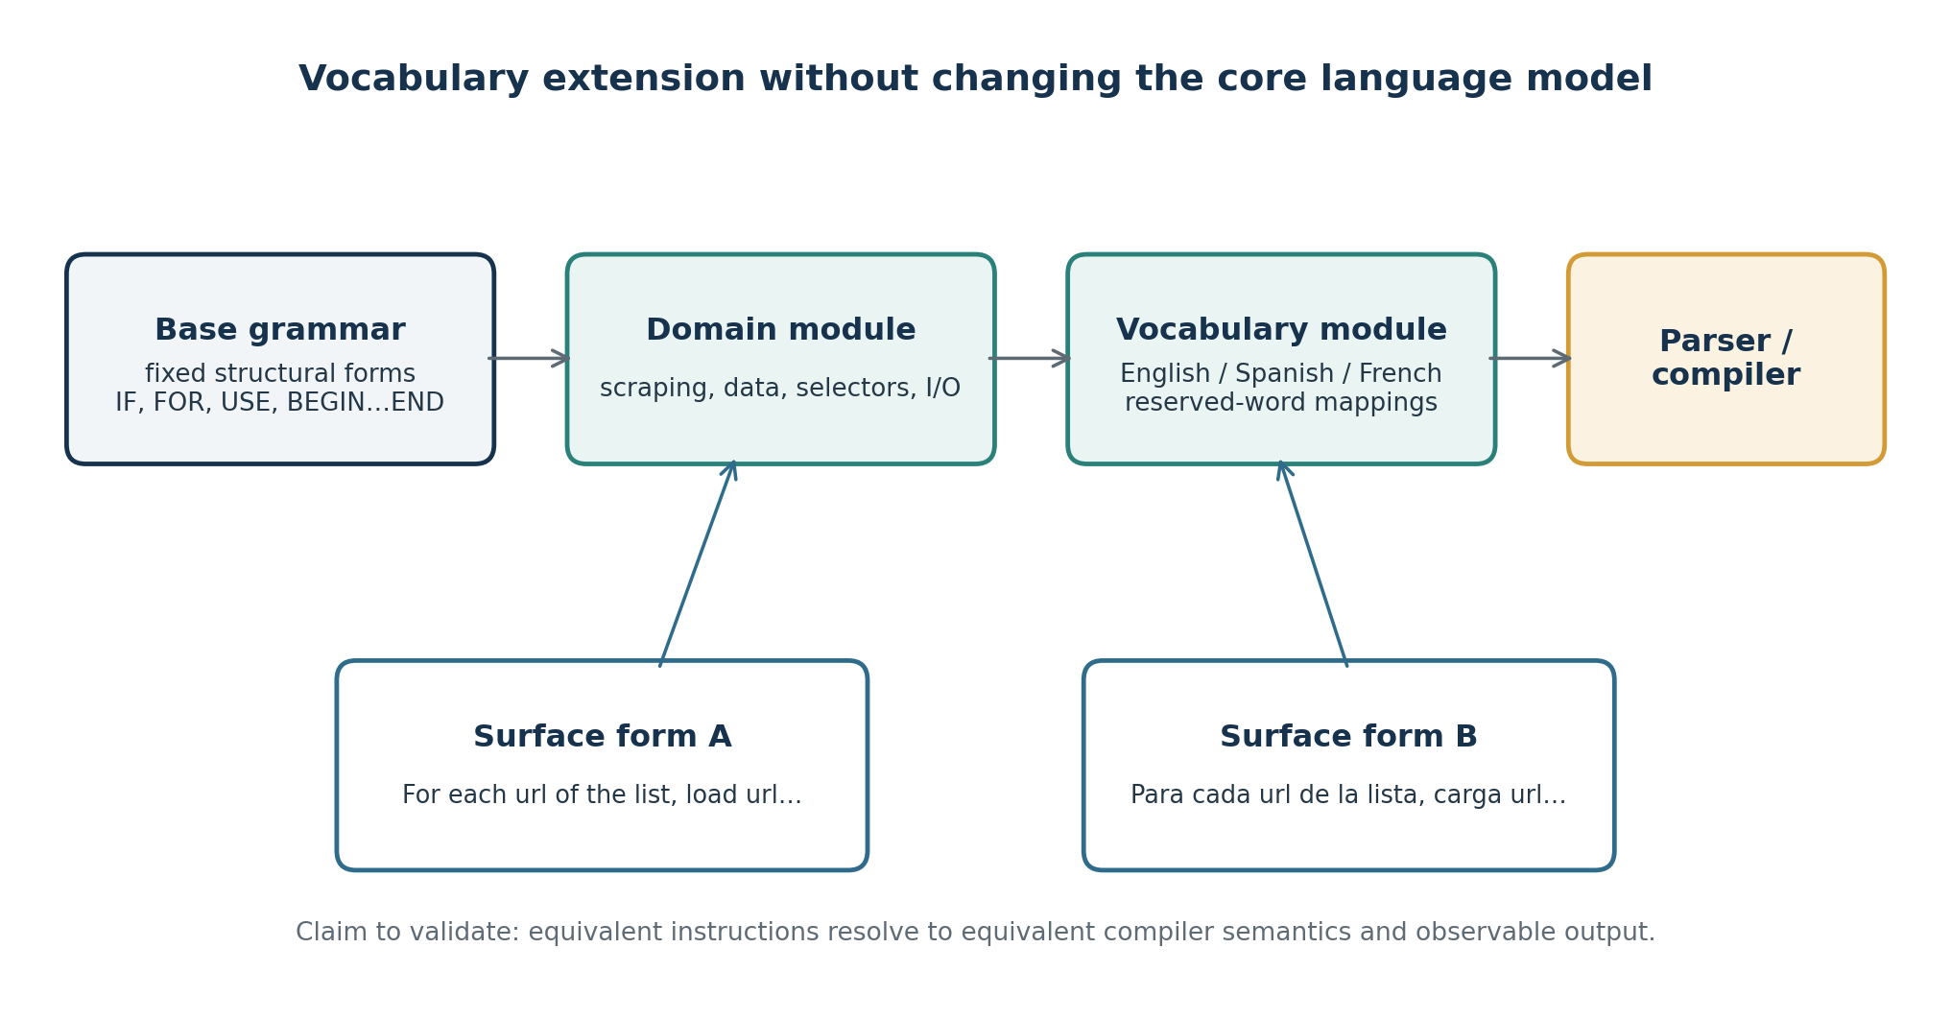
Figure 2. Intended vocabulary extension model: domain and language modules feed the same stable instruction grammar. Semantic equivalence is evaluated through paired fixtures.

5.9 Relationship to object-oriented, functional, and imperative code
DEAL.JS does not need to be classified as a purely object-oriented language. The current implementation directly interoperates with JavaScript, so programs can use target-language objects, functions, classes, and control structures to the extent that the compiler preserves them. DEAL’s own definition-command form can also introduce object-like structures. The careful claim is that DEAL.JS supports multiple programming styles through its higher-level commands and JavaScript interoperability; native object-oriented semantics should only be claimed to the extent that they are explicitly specified and tested.

6. DEAL.JS syntax reference
This section consolidates the principal syntax families documented in the project README. The language has been formalized in a versioned specification covering grammar, tokenization, precedence, module behavior, and diagnostics. Insert the exact specification file, version, and public artifact reference here: [specification file/URL and version]. The table below is a compact overview, not a replacement for the complete specification.
Syntax family | Illustrative DEAL form | Intended target form
Conditional | IF condition, procedure; ELSE procedure; | JavaScript if/else.
Collection loop | FOR EACH item OF collection, procedure; | for (item of collection) …
Object/property loop | FOR item IN object, procedure; | for (item in object) …
While loop | WHILE condition, procedure; | while (condition) …
Block | BEGIN procedures END; / DO procedures END; | JavaScript block.
Callable block | DOING procedures END; | Callable function/arrow function form.
Exception handling | TRY procedures; CATCH problem, procedure; FINALLY procedure; | try/catch/finally.
Promise-oriented flow | WILL procedure THEN procedure; OTHERWISE procedure; ANYWAY procedure; | Promise-oriented continuation chain, per documented translation.
Filtering | array WHERE condition | array.filter(…).
Ordering | array ORDER BY key1, key2 | Documented target uses sort operations; ordering semantics must be explicitly specified and tested.
Slicing | array LIMIT start, count | array.slice(start, count) per the current README example.
Module use | USE scraper; / USE deal\data\resource; | Module/resource inclusion at compile time.
Replacement reserve | RESERVE into AS ","; | Parser-level vocabulary replacement.
Noise reserve | RESERVE the; | Parser skips registered readability word.
Action command | # PrepareReport procedures; | Definition-time invocation plus callable name.
Function command | COMMAND normalize(value = "") { … } | JavaScript function.
Definition command | COMMAND settings = { key: value }; | Object-like value.
Delegation command | const #Destination = …; | Case-insensitive reference convention for the identifier.

6.1 Case behavior and Markdown-like readability
The README describes case-insensitive recognition for target-language structures and DEAL or third-party structures, commands, reserves, and handlers; user-defined variables/functions/constants and object properties are case-sensitive unless they are handled through the delegation convention. It also describes a Markdown-like visual convention: `*`, `-`, or `+` prefixed by one space can mark lines in a structured block, and asterisks can visually identify special references. The intended result is source code that is legible as a procedure document. Since this visual convention is language-specific, its interaction with comments, strings, JavaScript operators, and nested blocks belongs in the formal specification and conformance suite.

7. Compiler and implementation architecture

7.1 JavaScript-targeting compiler
The DEAL.JS-specific implementation is written in C# and exposes a `MiMFa.Engine.DEAL.JS.Engine` class that derives from `JavaScript.Engine`. Its default compilation stages are Tokenizer, Preprocessor, Parser, Assembler, and Generator. DEAL-specific Tokenizer, Parser, and Assembler implementations extend the corresponding JavaScript stages; the DEAL Preprocessor and Generator reuse their JavaScript base-stage implementations in the supplied snapshot. This is an important implementation choice: the language can add higher-level constructs without requiring a completely separate implementation of the target JavaScript grammar and output path [13, repository source].
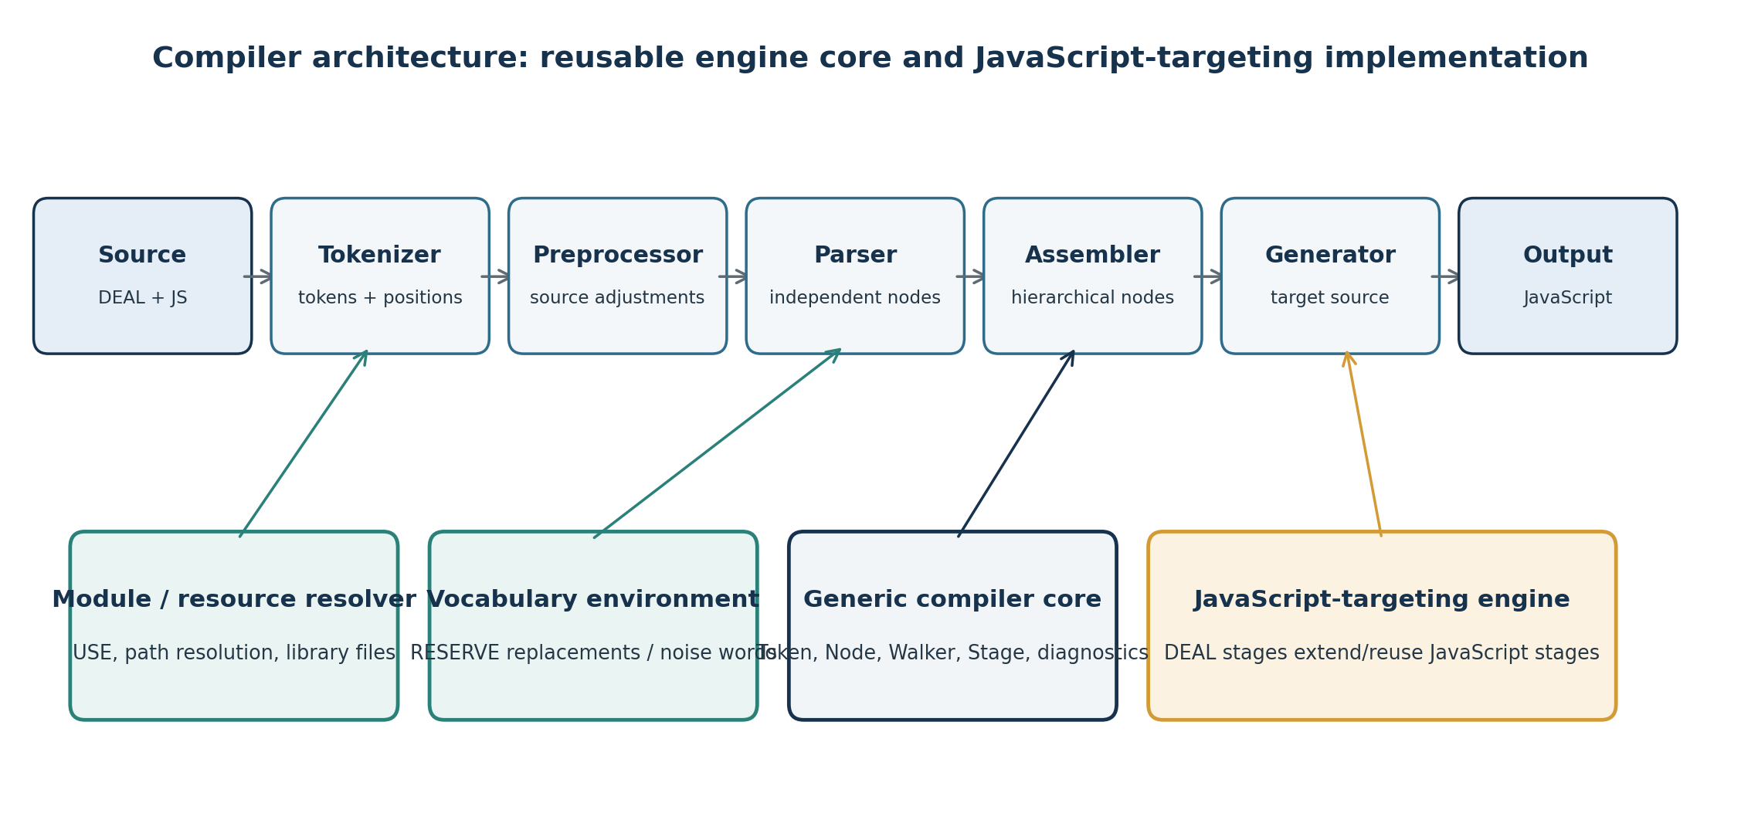
Figure 3. Compiler pipeline and supporting subsystems, synthesized from the DEAL.JS implementation and generic DEAL engine core in the supplied archive.

7.2 Tokenization and lexical environment
The JavaScript tokenizer classifies lexical elements, including identifiers, statements, operators, delimiters, comments, and literal forms. The DEAL tokenizer adds recognition of DEAL-specific directives and command forms and consults engine dictionaries for actions, functions, definitions, and reserves. The engine stores several command and reserve dictionaries with case-insensitive comparers, supporting the documented case behavior. `USE` and vocabulary definitions alter the lexical or parser environment; their ordering and inclusion semantics therefore need to be described as part of the compilation contract.

7.3 Parsing and assembly
The parser recognizes grammatical structures and creates nodes; the assembler groups related nodes into larger hierarchical structures. The distinction is architectural rather than merely organizational: the parser’s task is to identify local token/node forms, while the assembler establishes structural relationships required for generation. The general engine contains `Token`, `Node`, `TokenType`, `NodeType`, position/range models, and walkers such as `CodeWalker`, `TokenWalker`, and `NodeWalker`. Node types are represented as flags and the node model supports hierarchical children, parent relationships, cloning, and traversal. These models provide a basis for preserving source positions and reasoning over nested constructs.

7.4 Code generation and target source
The DEAL generator reuses the JavaScript generator in the supplied DEAL.JS-specific compiler. The generator emits JavaScript, including target-language forms for DEAL structures and command definitions. The documentation’s example maps a readable iteration and error path to a `for…of` loop with promise continuations. The generated output remains ordinary JavaScript and can be executed in an environment that supplies the referenced libraries and runtime objects. Any claims of optimization should be backed by emitted-code comparison and runtime benchmarks; the presence of source-to-source generation alone does not establish optimized performance.

7.5 Generic engine core and resource abstraction
The same archive also contains a separate generic DEAL engine project, with `Engine`, stage and stage-base abstractions, tokenizer/parser/assembler/generator components, an executor, input/output/options types, structured diagnostics, and a resource-provider interface. The resource abstraction includes operations such as existence checks, path normalization/resolution, listing directory contents, reading/writing file contents, and deletion. This supports a design in which language front ends and target-specific generators can be separated from the compiler orchestration and resource mechanism. The supplied archive contains a core architecture, but the verified target backend in the DEAL.JS project remains JavaScript; other target languages must be reported as implemented only when their corresponding generators and conformance tests are included.

7.6 Module inclusion and dependency behavior
The README’s module documentation indicates a resolution sequence across `.djs` library files, `.js` files, and directories. Modules can contain commands or reserves used by the source. For reproducible compilation, the completed implementation should record the resolved module graph and the version or content hash of each dependency. Add the exact semantics of duplicates, cycles, case-insensitive module identifiers, absolute/relative paths, and error recovery here: [exact implemented rules and specification references].

7.7 Compiler diagnostics and failure handling
The generic engine includes diagnostic types and severity models, logging, stage orchestration, and position/range types. These facilities are important for a language intended to be generated by AI because deterministic errors can support automated repair: the model can respond to a compiler diagnostic rather than guessing why generated source failed. To substantiate this contribution, report diagnostic categories, source-location precision, failure detection coverage, and whether AI repair was evaluated using actual compiler messages: [].

8. Worked application: research data extraction and processing
The repository’s tutorial sample describes a data-processing workflow that reads a source file, selects a field from each row, attempts an API request, falls back to loading a web page if the request fails, extracts rows from page elements, normalizes text, converts numeric fields, derives a price, follows pagination, and writes results to a destination. The source sample explicitly labels itself as a tutorial scenario that will not work as written. It should therefore be presented as an illustrative language example, while the completed executable version and fixture evidence should be linked here: [runnable sample path and test record].
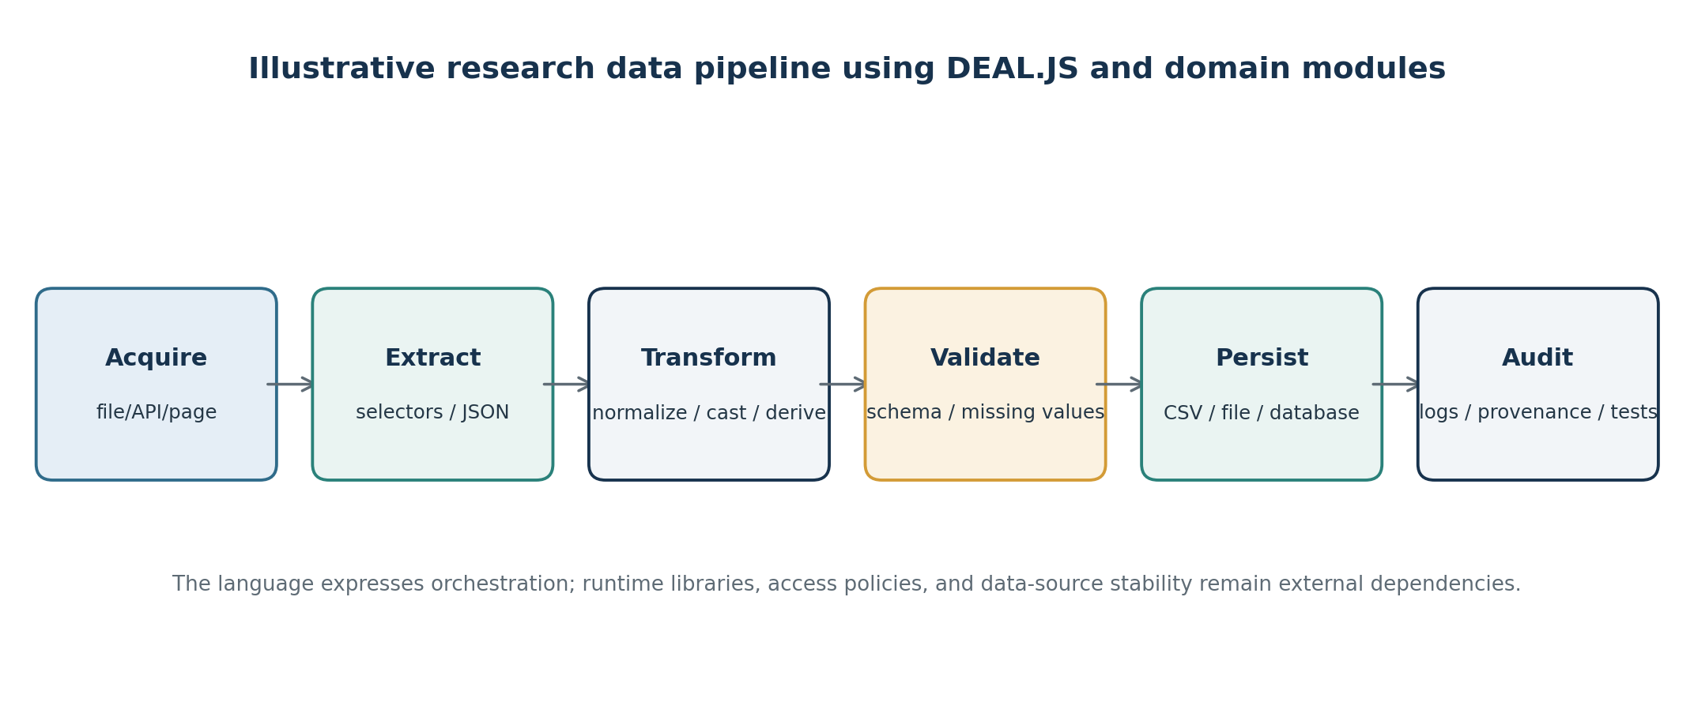
Figure 4. Data pipeline represented by the scraper-oriented repository examples. Acquisition, extraction, transformation, validation, persistence, and audit are separated conceptually.

8.1 Source-language example
USE scraper;
source = resource.openfile();
destination = resource.savefile("results", "Comma Separated Values Files (*.csv)|*.csv");
# DailyChack
For each row of file(source) rows, begin:
Let merchandise be row[5];
Try to fetch "api.market.com/search" with merchandise, then:
If fetched,
For each item of response json(),
Append destination, item;
Else load "www.market.com/search/merchandise=" + merchandise, then:
If loaded, do
For each item of all("div table>tbody>tr"),
Append destination, collect
normalize(concat(item[".company-title>*"], " ")) as company_name,
number item[7] as main_price,
main_price - discount as price;
Click any button#next-page;
Else log warning, `Could not load ${merchandise}!`;
Catch problem, log error problem;
End;
This shortened listing is adapted from the repository tutorial, which includes an explicit non-executable-example disclaimer. Endpoint names and runtime calls are illustrative. A publication-ready application experiment should replace those placeholders with deterministic mocked endpoints or a fully documented controlled environment and should record the exact generated target source.

8.2 What the example demonstrates
- Data acquisition: a source file is read and a web/API request is attempted, with an alternative path when the first method is unsuccessful.
- Data extraction: JSON responses or selected DOM rows provide input records, with CSS-like selectors used in the example vocabulary.
- Data transformation: text normalization, URL decoding, numeric conversion, and calculated fields are expressed as named commands or ordinary target-language expressions.
- Data storage: records are appended to a destination; error and warning statements make unsuccessful paths visible.
- Control and recovery: loops, try/catch, conditionals, retries, page navigation, and delayed recurring execution are shown in the larger sample.
The demonstrated benefit is not that DEAL eliminates the need for programming knowledge, data validation, or runtime configuration. Its aim is to make the orchestration of those operations more readable while keeping the underlying JavaScript functionality available. Scraping remains subject to site terms, authorization, rate limits, dynamic content, schema drift, and the availability of external services.

9. Evaluation methodology
The evaluation program is designed to establish both implementation-level properties and human/AI workflow outcomes. The author confirms completion of the five development and validation activities discussed after the first draft; this section provides the manuscript-level structure needed to document them reproducibly. Insert the actual experimental setup and results instead of leaving generic claims.

9.1 Artifact and environment
The submitted archive includes a DEAL.JS README, a tutorial, a library tree, and sample source/expected/generated result files. The stress-test corpus contains a DEAL-oriented test covering module inclusion, reserves, four command forms, exception handling, conditions, operators, Markdown-like code, and composed web-workflow instructions. A JavaScript stress test exercises a broad range of modern JavaScript constructs, including primitive values, object and array literals, nested objects, destructuring, spread/rest, functions and arrow functions, IIFEs, loops, conditionals, classes and async constructs in the larger fixture. The complex stress test combines JavaScript and DEAL syntax. These artifact families provide a useful base for regression and conformance testing [13].
[Test environment; OS, .NET SDK/runtime, JavaScript runtime/version, compiler release/commit, flags, dependency versions and hardware where relevant.]
[Test corpus inventory; Number of fixtures, total source lines, test categories, inclusion/exclusion rules, and final hashes.]

9.2 RQ1: compiler conformance and semantic preservation
The compiler validation distinguishes textual output equality from semantic equivalence. Textual diffs are used to detect formatting regressions and unexpected code-generation changes, but formatting differences do not necessarily indicate behavioral changes. Conversely, a tiny identifier, operator, binding, or control-flow change can alter semantics despite a visually similar output. The completed suite combines normalized-output regression tests with execution-based differential tests that run expected and generated programs with identical deterministic inputs and compare observable outputs, state mutations, errors, or emitted events.
The conformance corpus classifies cases by constructs and severity: tokenization, parser/assembly structure, generated syntax validity, runtime behavior, module resolution, reserve handling, mixed JavaScript/DEAL preservation, and diagnostics. Unsupported syntax is labelled explicitly rather than counted silently as a pass. The reported outcomes are fixture count, compile-success rate, execution-equivalence rate, and discrepancy distribution.
Measure | Result to insert
Total conformance fixtures | [N]
Fixtures compiled successfully | [n / N and %]
Fixtures passing execution-based equivalence | [n / N and %]
Formatting-only differences | [n]
Semantic mismatches / runtime failures | [n and classification]
Coverage categories / unsupported syntax | [list and counts]

9.3 RQ2: determinism and reproducibility
Repeated compilation was tested under the same pinned toolchain and options. Where output formatting is intended to be stable, output hashes or normalized bytes were compared. Generated output was also executed and its observable behavior compared to ensure that stable textual output did not conceal stable but incorrect behavior. Reproducibility artifacts include source fixtures, expected outputs, runtime configuration, module/dependency hashes, runner scripts, logs, and the exact repository version.
Reproducibility item | Implemented artifact / outcome
Versioned specification | [file, version, commit]
Automated test command / CI workflow | [command and workflow URL/path]
Repeated-build sample size and byte-stability | [N runs, comparison method, outcome]
Runtime and module pinning | [mechanism and manifest]
Public artifact availability | [repository/release/archive URL]

9.4 RQ3: AI-generation comparison
The AI-generation evaluation compared matched tasks using equivalent task descriptions. In one condition, the model produced JavaScript directly; in the other, it produced DEAL.JS, which was then compiled to JavaScript. The compiler’s diagnostics and target program were part of the DEAL condition. Task families covered control flow, JSON processing, data normalization, extraction, filtering, file output, and error handling. Model versions, temperatures, prompts, system instructions, retries, and time/cost limits were recorded as part of the protocol. The same prewritten functional tests were applied to both conditions. This approach follows the principle that code generation should be evaluated by executable correctness rather than the apparent plausibility of its output [1,2].
Study element | Author-completion field
Models and exact versions | []
Number and description of tasks | []
Trials per model/task/condition | []
Prompt templates and generation settings | [repository path or appendix]
Compile success: DEAL condition | [n/N, %]
Functional tests passed: DEAL vs JavaScript | [values and comparison]
Repair turns / latency / token or API cost | []
Statistical test, effect size, confidence interval | []

Interpretation must be modest: if DEAL performs better, the result applies to the tested task corpus, prompts, model versions, and language implementation. It does not establish universal superiority over JavaScript or unrestricted natural language. If results are mixed, report which task categories benefit and which do not.

9.5 RQ4: human comprehension and review
The human-comprehension study used matched tasks asking participants to explain a program’s purpose, identify where data are transformed, predict output, find a seeded defect, and make a small change. Its design, participant profile, task counterbalancing, training, and analysis should be documented in the highlighted fields below. Outcomes included task correctness, completion time, confidence, perceived workload, and qualitative reports. The manuscript reports eligibility, training, sample-size rationale, exclusion criteria, consent, and ethics-review information from the study protocol. Systematic DSL research cautions that usability claims are often made without adequate evaluation [8].
Study item | Author-completion field
Participants, experience groups, recruitment | []
Design, task set, counterbalancing, training | []
Ethics approval / consent process | []
Accuracy: DEAL vs JavaScript | [means/rates and dispersion]
Time and perceived workload | []
Statistical model/test, effect sizes, confidence intervals | []
Qualitative themes and coding method | []

9.6 RQ5: module and localization equivalence
Vocabulary extensibility and localization were evaluated using paired source programs that differ in surface vocabulary but are intended to encode the same instruction. For each pair, the programs were compiled using the appropriate module configuration and their resulting syntax/behavior was compared. The test set covered positive cases and failure modes, including unknown words, conflicting reserves, duplicate module definitions, casing, nested imports, and module-order changes. These tests assess whether localization maps to established instruction semantics rather than implementing unbounded translation of natural language.
Localization measure | Author-completion field
Languages and module identifiers tested | []
Paired equivalence fixtures | [N]
Pairs producing equivalent output/behavior | [n/N and %]
Known unsupported forms and ambiguity cases | []
Example localized pair and generated outputs | [artifact path or appendix]

9.7 RQ6: performance and operational costs
Supplementary performance measurements, if included in the final contribution, report compilation latency, peak memory, generated-code size, and target runtime behavior under reproducible conditions. Compilation overhead is separated from target-program runtime. Since the language primarily expresses operations executed by JavaScript, the runtime of generated code may be similar to a manually written program if the emitted source is semantically equivalent; this must be measured, not assumed. The number of runs, warm-up protocol, hardware, runtime version, summary statistics, and confidence intervals belong in the highlighted field.
[Performance results; compiler time, memory, output size, runtime comparisons, run count and statistical summaries.]

10. Results
This section is intentionally structured for insertion of the completed findings. It should be replaced with concise result statements that directly answer RQ1–RQ6 and refer to the tables, figures, test scripts, and raw artifacts. Do not replace missing values with qualitative labels such as “high,” “fast,” or “reliable” without operational definitions.

10.1 Compiler correctness and deterministic output
[RQ1/RQ2 result narrative; report exact pass rates, mismatch classification, repeated compilation stability, and relevant confidence intervals if appropriate.]

10.2 AI-generation outcomes
[RQ3 result narrative; report primary comparison, uncertainty, effect size, and task-category differences.]

10.3 Human-comprehension outcomes
[RQ4 result narrative; report participant profile, group comparison, accuracy/time, confidence, workload, and qualitative themes.]

10.4 Localization and reproducibility outcomes
[RQ5/RQ6 result narrative; report language-pair equivalence and reproducibility/artifact availability; include performance if measured.]

11. Discussion

11.1 What the results would establish
The evidence should be interpreted against the design claims, not against an undefined idea of “better programming.” Compiler conformance results can establish the behavior of the tested implementation on supported cases. Deterministic output results can establish stability under pinned conditions. AI-generation comparisons can show whether DEAL improves the success rate, cost, or repair effort for the tested tasks and models. Human-comprehension results can establish whether DEAL changes comprehension and review outcomes for the tested participant groups. Localization results can establish that particular vocabulary modules preserve defined behavior. None of these alone proves that DEAL makes neural models transparent or makes all programs reliable.

11.2 Contribution to programming-language design
The primary contribution is the integration of several design goals in a concrete programming language: constrained natural-language-like syntax, explicit compilation into JavaScript, interoperability with the host language, module-driven commands and vocabulary, and a research workflow in which AI and humans can share and inspect the same source artifact. Existing work demonstrates that each of these broader aims has precedents—human-oriented syntax [4,5,7], language extensibility [9], JavaScript-targeting translation [10,11], and web automation [12]. DEAL’s claim should therefore center on its particular design integration and the empirical evidence for its use in AI-assisted program development.

11.3 Contribution to researchers and domain specialists
For data-oriented researchers, DEAL may provide an accessible layer for describing extraction and transformation procedures while preserving JavaScript escape hatches for specialized behavior. It can support reusable domain vocabulary, explicit error paths, and output code that remains inspectable. The value for scientific workflows depends on operational requirements not fully guaranteed by the language: source provenance, external data stability, package versioning, access permission, schema validation, and data-management practice.

11.4 Interpreting modularity and additional targets
The `USE` mechanism and resource-provider abstractions make modularity a central implementation concern. Vocabulary modules can separate domain terms from the core grammar, and localized forms can map to the same semantic operations. The separate generic engine core suggests a path toward other target languages, but the current proof-of-implementation should be stated precisely: DEAL.JS targets JavaScript. A C#, Python, or other generator is a future contribution unless its complete implementation, specification mapping, and conformance tests are part of the evaluated artifact.

11.5 Threats to validity
Threat | Mitigation to report
Construct validity | Define readability, correctness, determinism, generatability, and reliability with measurable outcomes.
Internal validity | Use counterbalancing, fixed prompts, prewritten tests, pinned environments, and blinded grading where feasible.
External validity | Describe task domains, participant demographics/experience, model versions, and languages tested.
Conclusion validity | Report sample-size rationale, effect sizes, uncertainty intervals, and corrections for multiple comparisons.
Reproducibility | Release fixtures, scripts, exact versions, module manifests, prompts, logs, and analysis code where licensing permits.
Implementation scope | Report supported syntax, unsupported constructs, module conflicts, and all known limitations.

12. Limitations
The language and compiler operate within a defined host-language and module ecosystem. DEAL’s constrained surface syntax reduces the scope of acceptable inputs relative to unrestricted natural language; users still need to learn the supported grammar and vocabulary. Module-based extensibility can also introduce dependencies, naming conflicts, and inconsistent vocabulary unless resolution rules are explicit. JavaScript interoperability preserves expressive power but can weaken beginner-level simplicity when users embed complex target code. The tool’s current JavaScript target means that cross-target portability is an architectural direction, not an automatic consequence of the source language design.
Deterministic compilation should not be conflated with correctness, safety, optimization, or reproducibility of external data retrieval. A consistently compiled program may still contain an error; a correct program may rely on unstable web pages or APIs; and executable output may have side effects. The paper’s claims must therefore remain tied to the tested source forms, versions, libraries, execution environment, and evaluation tasks. The empirical study also has limits specified by its sample sizes, task construction, participant population, and chosen AI models.
The supplied README also advises avoiding JavaScript’s `"use strict";` directive because the current instruction conventions may rely on assignments without explicit declaration. This is an important compatibility and safety issue: the final specification should state whether this is a current implementation constraint, an intentional design decision, or a behavior to be removed. The study should also document the supported ECMAScript subset and whether comments, regular expressions, template literals, destructuring, async constructs, and semicolon handling are preserved in every mixed-source case.
[Implementation-specific limitations to add; document known compiler restrictions, supported ECMAScript version/features, parser edge cases, module-resolution constraints, and execution environment limitations.]

13. Future work
- Additional target-language generators: formalize which instruction semantics can be mapped across JavaScript, C#, Python, and other targets, and test each backend against a shared suite.
- Language-server and IDE tooling: add syntax highlighting, source diagnostics, source maps, code preview, and links between DEAL instructions and generated JavaScript fragments.
- AI feedback loop: connect constrained generation with compiler diagnostics and automated test feedback, while logging every repair cycle for reproducible evaluation.
- Vocabulary authoring tools: support module manifests, conflict detection, synonym maps, locale tests, and documentation for domain experts who define commands.
- Scientific workflow facilities: provide provenance, schema checking, controlled retries, caching, deterministic fixtures, and export metadata as reusable modules.
- Security and governance: define a trust model for imported libraries, filesystem/network capabilities, execution confirmation, and policy controls for scraping and other side-effectful operations.
- Longitudinal studies: evaluate whether users retain syntax knowledge, maintain DEAL programs over time, and transfer concepts between DEAL and conventional JavaScript.

14. Conclusion
DEAL is designed as a common executable language through which a person can express computational intent, an AI system can generate a structured program, and a compiler can translate that source into executable target-language code. DEAL.JS embodies this aim through constrained natural-language-like instructions, direct JavaScript interoperability, module inclusion, replaceable and ignorable vocabulary, and command abstractions for reusable behavior. The supplied project includes a C# DEAL.JS compiler that reuses JavaScript compiler stages and a general DEAL engine core with explicit models, walkers, resources, pipeline stages, and diagnostics.
The article’s scientific contribution depends not only on these implementation details but also on the completed evaluation evidence. Conformance and reproducibility results can establish compiler behavior; AI-generation and comprehension studies can test the communication-layer hypothesis; and localization tests can determine whether vocabulary adaptation preserves semantics. With these data inserted and the artifacts made available, the paper can make a well-bounded contribution to programming-language design and AI-assisted end-user programming. The manuscript therefore closes with the central claim as a testable proposition: DEAL offers a structured, inspectable, and extensible source representation that may help connect human intent, AI-generated code, and executable software without relying on unrestricted natural-language interpretation.

Acknowledgements
[Acknowledgements; funding, lab support, participants, collaborators or leave blank if none.]

Data and code availability
The compiler source, language examples, test corpus, experiment prompts, test runner, analysis scripts, and raw de-identified results are available at [repository/release URL]. The artifact version evaluated in this study is [commit SHA/tag/archive hash].

Ethics statement
[Ethics statement; provide approval identifier or explain why approval was not required; include informed-consent statement for participant studies.]

Conflict of interest
[declare conflicts of interest, or state that there are none.]

Appendix A. Language grammar excerpt
The following compact grammar is a readable specification fragment based on the structures documented by the DEAL.JS README. It is intentionally an excerpt: insert the versioned complete grammar and resolve any variation between examples and implementation before treating it as normative.
program ::= item*
item ::= useDirective | reserveDirective | structure | commandDefinition | targetLanguageItem
useDirective ::= USE modulePath ";"
reserveDirective ::= RESERVE identifier (AS stringLiteral)? ";"
conditional ::= IF expression "," statement (ELSE statement)?
iteration ::= FOR EACH? identifier (OF | IN) expression "," statement
whileLoop ::= WHILE expression "," statement
block ::= (BEGIN | DO) statement* END ";"
callableBlock ::= DOING statement* END ";"
tryStatement ::= TRY statement* (CATCH identifier? statement*)? (FINALLY statement*)?
functionCommand ::= COMMAND identifier "(" parameters? ")" block
definitionCommand ::= COMMAND identifier "=" objectLiteral ";"
actionCommand ::= HASH+ identifier statement
delegatedReference ::= HASH identifier | ASTERISK identifier ASTERISK
targetLanguageItem ::= JavaScript syntax accepted by the target parser
Notation and precedence require a complete specification: the excerpt uses `expression`, `statement`, `objectLiteral`, `modulePath`, `JavaScript syntax`, and `identifier` as nonterminals whose definitions are omitted here. It also does not attempt to encode every handler, collection operator, promise-oriented form, comment/Markdown-like convention, or command calling style.

Appendix B. Repository artifact map
Artifact in supplied archive | Role in manuscript | Final citation/version field
MiMFa DEAL.JS - Engine/README.md | Principal language definition, design principles, syntax reference, translation examples. | [commit/hash]
MiMFa DEAL.JS - Engine/SAMPLE.md | Tutorial and `USE`/library resolution explanation; explicitly notes that tutorial scenario will not work as written. | [verified runnable replacement]
MiMFa DEAL.JS - Engine/DEAL.JS/*.cs | DEAL.JS-specific engine, tokenizer, parser, assembler, preprocessor, generator. | [final code paths/release]
MiMFa DEAL.JS - Engine/JavaScript/*.cs | Base JavaScript compiler stages reused by DEAL.JS. | [tested target-language version]
MiMFa DEAL.JS - Engine/Library/deal/** | Core, data, selector, handler, conversion and web libraries. | [package manifest]
MiMFa DEAL.JS - Engine/Samples/*.djs and *Expected.js/*Result.js | JavaScript, DEAL and complex stress-test fixtures and comparison artifacts. | [fixture count and executed results]
MiMFa DEAL - Engine/Engine/** | Generic compiler engine, models, walkers, resource provider, stage and diagnostic architecture. | [release/commit and test evidence]
MiMFa DEAL - Environment/** | Environment project, runtime entry point and initialization/manual/final library resources. | [tested environment/runtime version]
MiMFa DEAL-X/profile/README.md | Compact overview of DEAL principles and role. | [exact public URL if citable]

Appendix C. Result tables to complete
Insert the final values below only after verifying them against the scripts/logs included in the artifact bundle.
Evaluation dimension | Metric | Value
Compiler conformance | Fixtures run / pass rate | []
Behavioral equivalence | Expected-vs-actual observable behavior | []
Determinism | Repeated-build byte stability | []
AI generation | Compile success and functional correctness | []
AI generation | Repair effort and token/time cost | []
Human study | Accuracy, time, confidence/workload | []
Localization | Equivalent behavior across language modules | []
Performance | Compile time, memory, output size/runtime | []
Reproducibility | Artifacts available and independent reproduction status | []

References
[1] J. Liu, C. S. Xia, Y. Wang, and L. Zhang, “Is Your Code Generated by ChatGPT Really Correct? Rigorous Evaluation of Large Language Models for Code Generation,” Advances in Neural Information Processing Systems, vol. 36, 2023. https://proceedings.neurips.cc/paper_files/paper/2023/hash/43e9d647ccd3e4b7b5baab53f0368686-Abstract.html
[2] M. Chen et al., “Evaluating Large Language Models Trained on Code,” arXiv:2107.03374, 2021. https://arxiv.org/abs/2107.03374
[3] A. Adadi and M. Berrada, “Peeking Inside the Black-Box: A Survey on Explainable Artificial Intelligence (XAI),” IEEE Access, vol. 6, pp. 52138–52160, 2018. https://doi.org/10.1109/ACCESS.2018.2870052
[4] A. W. Biermann, B. W. Ballard, and A. H. Sigmon, “An experimental study of natural language programming,” International Journal of Man-Machine Studies, vol. 18, no. 1, pp. 71–87, 1983. https://doi.org/10.1016/S0020-7373(83)80005-4
[5] J. Good and K. Howland, “Programming language, natural language? Supporting the diverse computational activities of novice programmers,” Journal of Visual Languages & Computing, vol. 39, pp. 78–92, 2017. https://doi.org/10.1016/j.jvlc.2016.10.008
[6] B. R. Barricelli, F. Cassano, D. Fogli, and A. Piccinno, “End-user development, end-user programming and end-user software engineering: A systematic mapping study,” Journal of Systems and Software, vol. 149, pp. 101–137, 2019. https://doi.org/10.1016/j.jss.2018.11.041
[7] C. V. Lopes, P. Dourish, D. H. Lorenz, and K. Lieberherr, “Beyond AOP: Toward Naturalistic Programming,” ACM SIGPLAN Notices, vol. 38, no. 12, pp. 34–43, 2003. https://doi.org/10.1145/949344.949400
[8] A. Barisic, V. Amaral, M. Goulão, and B. Barroca, “How to reach a usable DSL? Moving toward a Systematic Evaluation,” Electronic Communications of the EASST, vol. 50, 2012. https://doi.org/10.14279/tuj.eceasst.50.741
[9] S. Erdweg, T. Rendel, C. Kästner, and K. Ostermann, “SugarJ: Library-based Syntactic Language Extensibility,” in Proceedings of OOPSLA 2011, ACM SIGPLAN Notices, vol. 46, no. 10, pp. 391–406, 2011. https://doi.org/10.1145/2076021.2048099
[10] G. M. Bierman, M. Abadi, and M. Torgersen, “Understanding TypeScript,” in ECOOP 2014 – Object-Oriented Programming, Lecture Notes in Computer Science, vol. 8586, pp. 257–281, Springer, 2014. https://doi.org/10.1007/978-3-662-44202-9_11
[11] M. Hanus, “Putting Declarative Programming into the Web: Translating Curry to JavaScript,” in Proceedings of the 9th ACM SIGPLAN International Conference on Principles and Practice of Declarative Programming (PPDP ’07), pp. 155–166, 2007. https://doi.org/10.1145/1273920.1273942
[12] T. Kistler and H. Marais, “WebL—a programming language for the Web,” Computer Networks and ISDN Systems, vol. 30, issues 1–7, pp. 259–270, 1998. https://doi.org/10.1016/S0169-7552(98)00018-X
[13] M. Fathi, “DEAL.JS (Declarative and Extensible Abstract Language for JavaScript) Compiler,” project README, C# implementation, library modules, and samples, repository snapshot supplied by the author, 2026. [public repository URL, release/commit hash, access date].

